8. Performance Monitoring and Tuning:

Tips for Long-Term Use V.2. V.2.3

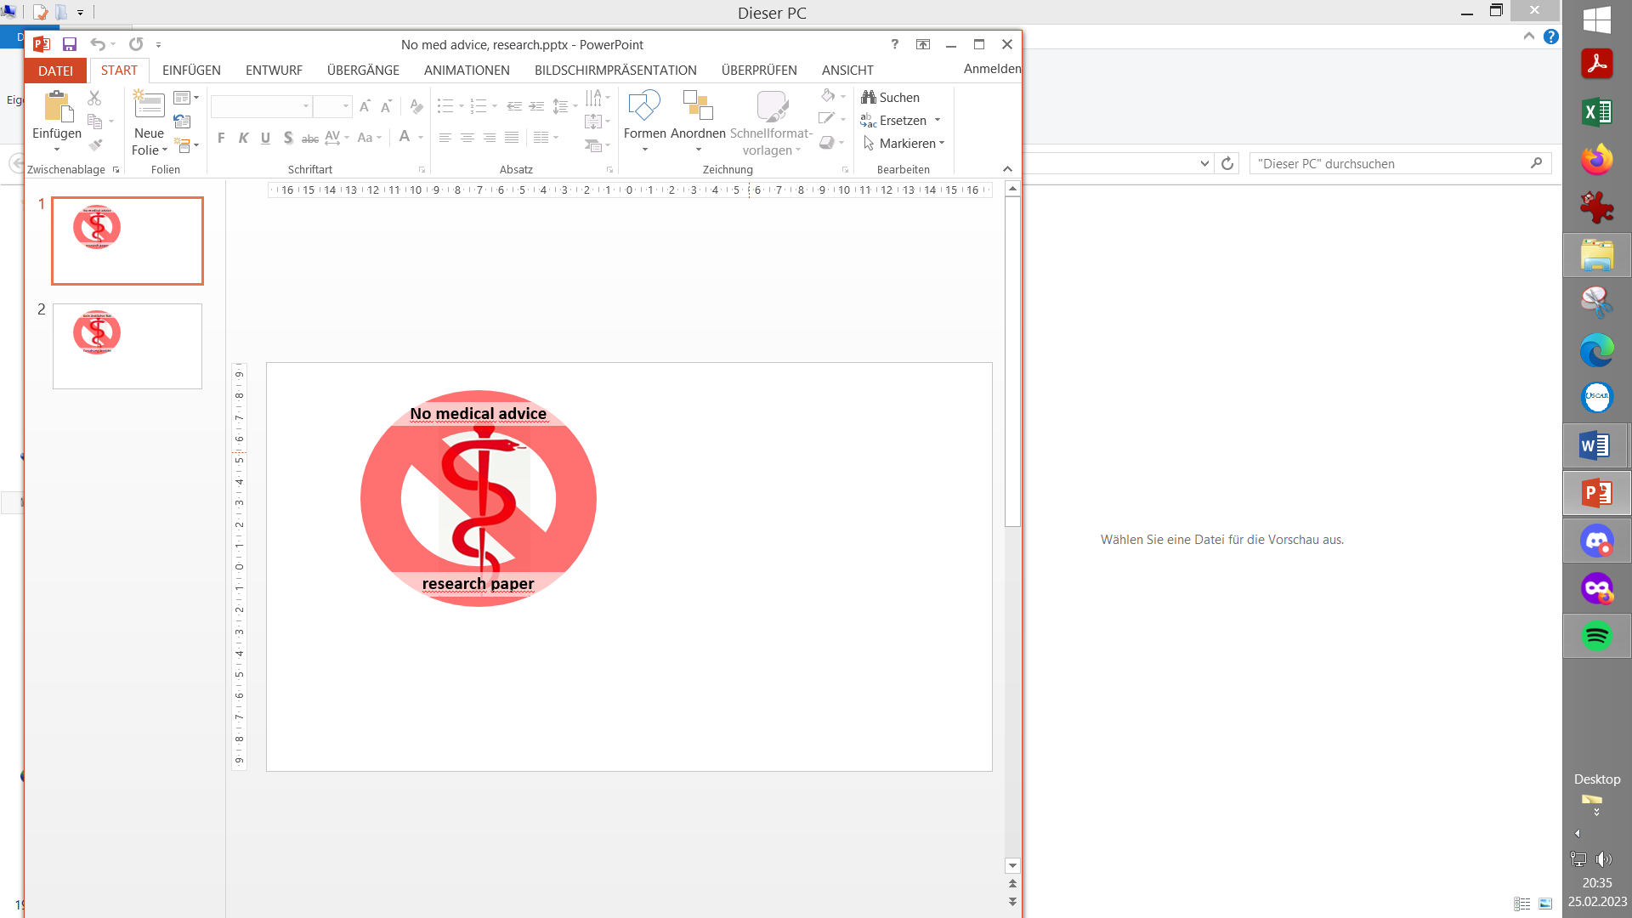

**Please note that with autoISF you are in an early-dev. environment**, where the user interface is **not optimized for safety** of users who stray away from intended ways to use.Good safety features exist, but these are only as good as the development-oriented user understands and implements them. This is not a medical product, refer to disclaimer in section 0

V14

Available *(related)* case studies:

Case study 8.2: Futility of tuning based on 1 extreme meal *(8.3)*

8.1 “Everyday life” with your FCL

8.2 Monitoring %TIR performance

8.3 To tune or not to tune

8.1 „Everyday life“ with your FCL

After the first tuning you have "earned" an opportunity to **let the loop run really easily**. That's what Full Closed Loop is all about.

It should be enough to **keep an eye on the weekly %TIR** on a rolling basis (-> 8.2).

Only if the danger of falling out of your desired range appears, it is time to consider what the reason could be. Consult the trouble shooting section 9.

For good performance, how your glucose curve and iob develop **before** a meal is important.

* Bad: Rising glucose and negative or very low iob
* Good: Slightly decreasing glucose, and building up some positive iob.

Both decreasing glucose and pos.iob could be supported by setting an EatingSoonTT, which can also be automated.

Sometimes you might get into a rhythm, a bit like surfing. Having a small appetizer can be surprisingly good. Also, a late little dessert, such as dark chocolate or a cracker with fatty cheese, can work wonderfully, utilizing the insulin tail that is "lurking" to still take effect.

If you can develop a certain mindfulness, while remaining relaxed and positive-looking ahead, that may be the best recipe for good success ... not every time, but more and more often.

8.2 Monitoring %TIR Performance

Just looking at the xDrip (*the author finds the 7 day 24hr scatter diagram particularly helpful for a quick orientation*) or the more extensive info from e.g. Nightscout Reporter, often helps:

* What time of day/night are the outliers happening?
* Are certain meals or snack habits to blame?

If so, maybe just a behavioral correction might be indicated to avoid making things unnecessarily difficult for the loop, or maybe employing some measures as discussed in sections 5. and 6.

* Do exercise or hormonal/disease-related sensitivity fluctuations interfere?

If so, as already known from the Hybrid Closed Loop, the profile, which also underlies the Full Closed Loop and autoISF, would have to be temporarily adjusted on a percentage basis. And regarding exercise, the options discussed in section 6. might be utilized better.

You could consider to define a User action Automation (section 5.2.2.3) for any special situation that you needed different settings for, shelve it as a currently-not-in-use Automation, and activate when the situation might come around again later.

* Do the changes correlate with age of insulin delivery, CGM dropouts, etc.?

"Outliers" to very high TDD and high % in the hyper range are often a sign that there was a partial occlusion, and that has then zero to do with your Full Loop settings.

You have to pay attention to the loop to ensure it always works **technically** well, and it has reliable iob and glucose data.

A time-consuming re-adjustment of the numerous autoISF parameters should only be necessary in exceptional cases, if radical changes occur in the lifestyle and habits and adjusting the key profile parameters in Open Loop might not be sufficient.

8.3 To Tune or not to Tune …

Note that an attempt to „fine-tune“ based on data from just one kind of meal (or, worse, an attempt to cover “also” an extreme event very well), easy can lead to a deterioration of your FCL performance. (See case study 8.2). Settings do not have to be great for any *one* event you may be looking at. They must suit „well-enough“ *most* of what you encounter in your personal life.

Note: If you differentiate your autoISF settings between meals (e.g. tied to time slots during the 24 hrs, section 5.1.4), this might *) somewhat ease your job to find suitable settings for your autoISF parameters that can cover the expected different meal spectra (…that is, if the kinds, sizes.of meals differ very much. - If it is just the insulin sensitivity that differs, this should be covered in your circadian ISF profile, on which autoISF builds).

*) Only the main two parameters (bgAccel_ISF_weight for “initial aggressiveness”, and iobTH_percent for “where SMBs stop”) are available in Automations for doing this. So, finding your parameter sets *for each of* the time slots, will not be trivial. => Spending more effort to set the .._weights so they accommodate *just one, broader* spectrum should be the first, and standard, approach.

An intermediate (maybe only temporary) approach could be to use a profile switch (for low carb meal, or eating half, setting %profile to 60% for instance, and only for the brief, less than an hour, initial meal period). See section 5.2.2.

Over time, you learn which events (meals, snacks, activities) likely contribute to being out-of-desired range. Efforts then could be targeted for instance at improved temporary settings (maybe even aided by an extra temp. button in your FCL cockpit (section 5.2.2.3)), or at real-time nudging, both discussed in sections 5. and 6.

Consult also section 9. (Trouble shooting).